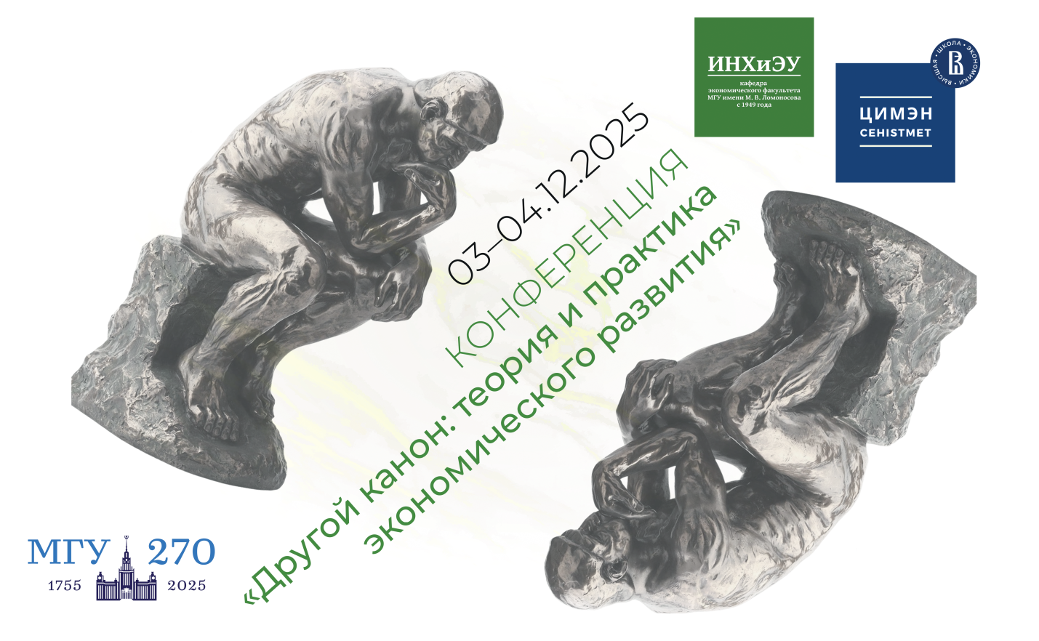

The other canon: the theory and practice of economic development
3-4th of December 2025

Call for Paper

The international conference, "Other Canon: Theory and Practice of Economic Development" will take place on December 3-4, 2025, in Moscow at the Faculty of Economics of Moscow State University.

The well-known contradistinction between two canons in economic science, proposed by E. Reinert in his book “How Rich Countries Got Rich…” (2007) provoked the idea for the conference. Among characteristics of the "other canon," two important ones are: 1) dynamic approach to economic analysis; 2) practice-oriented research. These characteristics defined the problems that we propose to discuss during the conference.

1. The origin and development of dynamic analysis in economics

It is normally assumed that dynamic theories emerged in economics only in the mid-20th century. Were there elements of dynamic analysis in previous periods? What were the historical and methodological origins of dynamic analysis? How do static and dynamic analysis relate?

2. The relationship between theory and practice in economic science

Science should produce an objective knowledge. This ideal, applied to the social sciences, leads to the attempts to clear the theory from the influence of vested interests (economic, legal, moral). What follows is creation of a “pure” theory that does not address concrete practical problems.

Does the pursuit of practical goals hinder objective analysis? What are the bridges between economic theory and practice? Is practice a field for testing theoretical models? To what extent do economic reforms, economic policy, and private business practices follow theory? To what extent are theories attentive to practice as a source of empirical data?

In the framework of this topic separate sections dedicated to the Kosygin reform and the economic policy of S.Witte will be organized.

3. Historical forms of economic education

Economic knowledge has taken various forms throughout its history. It has been a branch of public administration, moral philosophy or legal sciences, an applied branch of natural science, or an independent discipline.

When and how the forms of economic education have changed? What disciplines have formed and continue to form the structure of economic education? What trends are emerging now in this field?

4. Can the “other canon” be really considered a separate tradition of economic knowledge?

In the work of E. Reinert, the boundaries of “other canon” are defined quite clearly.
Are they correct? What are the historical and methodological origins of that approach, and can they be determined? Can we see the differences between countries in their adherence to this or that canon? Can we classify economists as supporters of this or that approach?

As part of the conference, it is also planned to organize the section for young participants «History of Russian reforms in the context of global economic development»

Organizational details:

- on-line and off-line participation
- address: Moscow, Leninskie Gory, Building 1, Bldg. 46; Third Academic Building

- for any further information and for abstracts please contacts us: inh.econ@org.msu.ru
- website of the conference: https://www.econ.msu.ru/departments/inh/Events.20250921105730_5300/

Important Dates:
- Last Date for abstracts admission: 15th of November 2025
- Notification of Selected abstracts: 25th of November 2025
- Registration of participant without a report: 30th of November 2025

Organizers:
- Department of the History of National Economy and Economic Thought of the Faculty of Economics at Lomonosov Moscow State University
- Center for the History and Methodology of Economic Sciences (CHMES) at the Higher School of Economics

